**Pittsburgh Bus Utilization**

Eric Laslo, [ERL67@pitt.edu](mailto:ERL67@pitt.edu)

This project visualizes the ridership and route utilization of PRT busses from 2017 to the present.

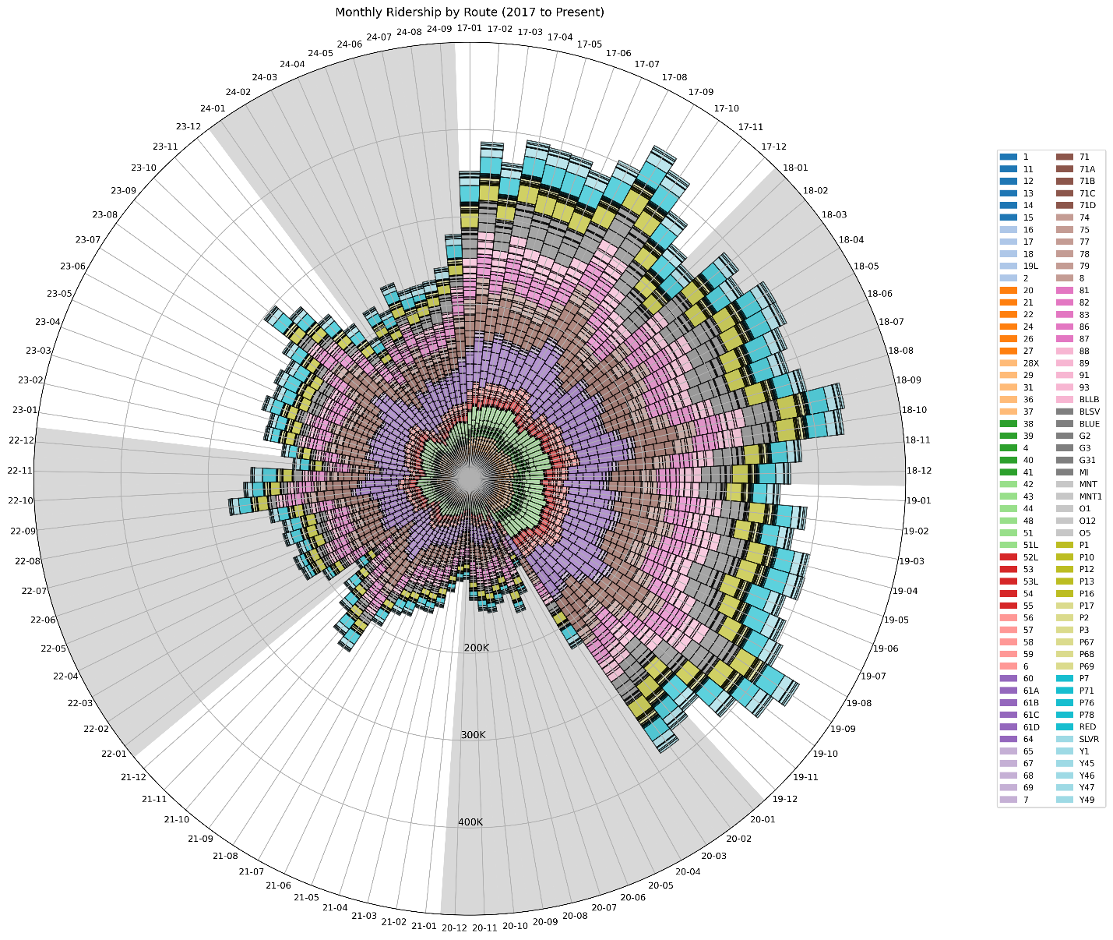

Legend:

* The outer circle denotes the month, going clockwise from Jan 2017 to Aug 2024
* Each large pie slide represents the total year, and the small increments represent the month
* The length of the bar is the total monthly ridership
* Each bar is divided into the individual routes by color
* The bar color groupings generally align with the various routes and make it easier to see
* The radii of the circle denotes the total ridership in intervals of 100,000

Findings:

* I thought it would be interesting to visualize the effects of Covid-19 on ridership.
* I also live in the city and ride the bus occasionally and wanted to see route variations.
* The graph shows how much the ridership dropped during the pandemic, starting March 2021.
* The graph also shows how the ridership has only recovered to approximately 65% of pre-pandemic levels.
* It’s also interesting to see how ridership spikes in August and September when school starts.
* Data was manipulated in Pandas based off a previous data analysis class I did in undergrad, and the design was tweaked by GPT-4o to look better.

Data:

Significance:

Github: <https://github.com/erl67/InfoVizProject>